

|  |  |
| --- | --- |
| NIGERIA STOCK MARKET  -INVESTMENT OUTLOOK AND OPPORTUNITIES |  |

|  |
| --- |
| Prepared By: Mmachi Goodness Paul -Emeka Date:28th JUNE 2024 – 2025 YTD (I8 - MONTH PERIOD) |

Table of Contents

Nigeria Stock Market 1

Executive summary 3

Stock Market Overview 4

Stock Market Performance by Sector : 2024 vs 2025 (Trailing Six-Month Performance) 5

Sector Performance Comparison Table 5

Sector Performance Comparison Chart 6

Professional Analysis and Key Insights 6

Key Market Trends 7

Top Performing Stocks in 2025 8

Macroeconomic Overview and Stock Market Implications 10

Stock Market Implications 11

Investment Opportunities 11

Key Investment Risks 12

Strategic Recommendations 12

Summary 12

References 13

## Executive summary

This report provides a focused analysis of the Nigerian stock market performance for 2025, based on trailing six-month sector returns. It compares sector movements to 2024, identifying key shifts in investor sentiment and emerging market trends.

While 2024 was marked by broad-based growth across Communication Services, Technology, and Consumer Discretionary sectors, 2025 reflects a sector rotation towards more defensive industries such as Consumer Staples and Utilities. Growth sectors slowed significantly, and cyclical sectors, including Energy and Real Estate, recorded substantial declines.

Opportunities in 2025 are likely to be found in consumer-focused, banking, and export-oriented sectors, supported by easing inflation and favorable currency conditions for exporters. However, risks remain elevated due to continued naira depreciation, tight monetary policy, and Nigeria’s exposure to global oil price fluctuations.

Investors are advised to adopt a selective, sector-focused strategy while managing currency and macroeconomic risks carefully.

## Stock Market Overview

This market research provides an in-depth analysis of the Nigerian Stock Market with a focus on identifying profitable investment opportunities and understanding the associated risks.

The stock market experienced mixed performance between January 2024 and June 2025, with notable periods of strong growth and significant downturns.

November 2024 recorded the highest monthly gain at 5.4%, followed closely by May 2024 (4.9%) and February 2024 (4.8%), indicating periods of strong market optimism and positive investor sentiment.

The most significant market drop occurred in March 2025, with a sharp decline of -6%, suggesting a possible market correction or response to unfavorable economic events. Other notable declines were in April 2024 (-4.2%) and December 2024 (-2.6%).

Despite the April 2025 dip, the market quickly rebounded with gains in May 2025 (5.1%) and June 2025 (4.1%), signaling renewed investor confidence.

The market showed resilience overall, with more months of positive returns than negative ones during the 18-month period. However, the recurring periods of volatility highlight the need for careful monitoring of market drivers and macroeconomic indicators.

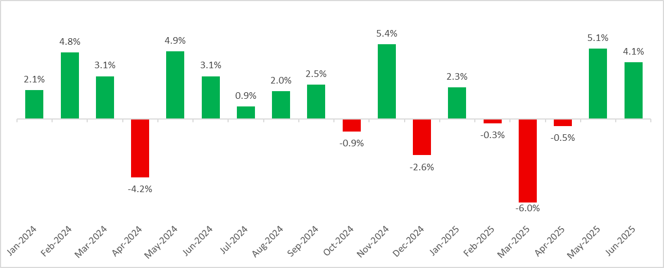

## Stock Market Performance by Sector : 2024 vs 2025 (Trailing Six-Month Performance)

This analysis presents the sectoral stock market performance in Nigeria based on 2024 and 2025 (trailing six-month returns). The trailing six-month performance measures the percentage change in sector indices over the most recent six-month period, providing timely insight into current market trends and investor sentiment across sectors.

## Sector Performance Comparison Table



## Sector Performance Comparison Chart

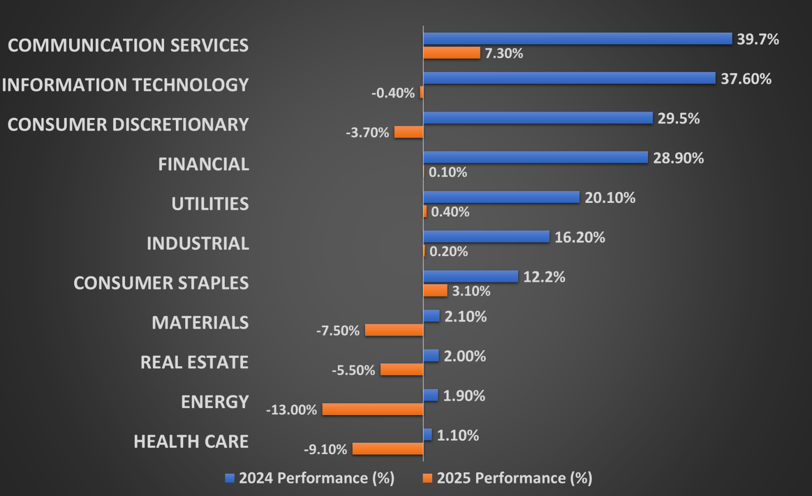

## Professional Analysis and Key Insights

* 2024 Growth-Driven Stock Market Rally

In 2024, the Nigerian stock market saw strong gains across growth-oriented sectors:

* Communication Services (+39.7%) and Information Technology (+37.6%) led the market, driven by investor appetite for high-growth assets and sector expansion.
* Consumer Discretionary (+29.5%) and Financials (+28.9%) also performed strongly, reflecting robust consumer spending and solid banking sector fundamentals.
* The broad-based growth in 2024 was likely supported by improved earnings, positive investor sentiment, and favorable liquidity conditions.
* 2025 Sector Rotation and Market Correction

In contrast, 2025 trailing six-month performance indicates a notable sector rotation:

* Communication Services slowed to +7.3%, while Information Technology and Consumer Discretionary recorded negative performances (-0.4% and -3.7% respectively).
* Financials and Industrials posted minimal gains, suggesting reduced market enthusiasm compared to the previous year.
* Defensive sectors such as Consumer Staples (+3.1%) and Utilities (+0.4%) gained modestly, indicating a shift in investor preference toward safer, more stable stocks.
* Energy (-13.0%), Health Care (-9.1%), Materials (-7.5%), and Real Estate (-5.5%) experienced significant declines, signaling pressure on cyclical and resource-dependent sectors.

## Key Market Trends

* Shift from Growth to Stability:  
  The sharp drop in performance across growth sectors suggests a movement towards risk aversion, likely influenced by macroeconomic challenges such as naira depreciation, monetary tightening, and slowing GDP growth.
* Defensive Sector Resilience:  
  Sectors like Consumer Staples and Utilities, known for their stability in uncertain markets, maintained positive but subdued growth in 2025.
* Cyclical Weakness:  
  Energy, Real Estate, and Materials, which are typically sensitive to economic cycles, underperformed in 2025, reflecting lower commodity prices, currency pressures, and reduced investor risk appetite.

## Top Performing Stocks in 2025

Investors continue to closely monitor the S&P 500 and its leading constituents as a gauge of market momentum and investment potential. While past performance is not indicative of future results, certain companies such as Amazon and Apple have consistently provided valuable signals of potential market outperformance. The table below highlights some of the best-performing stocks within the S&P 500 for the year 2025, which may offer insights into current market trends and investor sentiment.



In addition to tracking top gainers, it is essential to evaluate stocks that have lagged behind the broader index. Historical market cycles suggest that underperforming stocks in the current period may present potential upside opportunities in the future. Investors may find value in identifying fundamentally strong companies currently trading at discounted levels, as these could offer attractive entry points for long-term positions.



## Macroeconomic Overview and Stock Market Implications

The table below highlights key macroeconomic indicators for Nigeria in 2024 and 2025. These indicators are critical in shaping the performance and investor sentiment in the Nigerian stock market.

* Exchange Rate (₦/USD):

The exchange rate depreciated from ₦1,472.14/USD in 2024 to ₦1,549.03/USD in 2025, indicating further naira weakness. A depreciating naira often raises import costs, puts pressure on inflation, and can reduce foreign investor confidence in the equity market.

* Monetary Policy Rate (MPR):

The MPR remained unchanged at 27.50% across both years, signaling a sustained tight monetary policy stance aimed at curbing inflation. Elevated interest rates can make borrowing more expensive for companies, potentially slowing business expansion and affecting stock valuations, particularly in interest-sensitive sectors like banking and consumer goods.

* Inflation:

Inflation is projected to decline significantly from 34.80% in 2024 to 22.97% in 2025. This moderation may improve consumer purchasing power and corporate profit margins, potentially supporting a positive stock market outlook if sustained.

* Gross Domestic Product (GDP) Growth:

GDP growth is expected to slow from 3.84% in 2024 to 3.20% in 2025, suggesting a potential deceleration in economic activity. Slower GDP growth may dampen corporate earnings projections, although the easing inflation environment could offset some of these pressures.



## Stock Market Implications

* Positive Outlook: The expected decline in inflation could improve investor confidence and increase disposable income, which is favorable for sectors like consumer goods, manufacturing, and financial services.
* Risk Factors: Continued exchange rate depreciation and high interest rates may discourage foreign portfolio inflows and impact sectors heavily reliant on imports.
* Overall: The Nigerian stock market in 2025 may experience a cautiously optimistic environment, balancing between macroeconomic adjustments and sector-specific opportunities.

## Investment Opportunities

* **Consumer Goods & FMCG Sector**

**Rationale**: The anticipated reduction in inflation is likely to improve consumer purchasing power, supporting a recovery in consumer spending.

**Outlook**: Companies in food, beverages, and essential consumer products are well-positioned for potential revenue and margin growth.

* **Banking & Financial Services**

**Rationale**: A stable high-interest environment is expected to sustain strong interest income for banks, especially those with minimal foreign debt exposure.

**Outlook**: Financial institutions with solid balance sheets may outperform, driven by net interest margins and stable asset quality.

* **Export-Oriented Industries**

**Rationale**: Naira depreciation enhances the competitiveness of Nigerian exports.

**Outlook**: Sectors such as agriculture, manufacturing for export, and oil & gas may benefit from favorable exchange dynamics.

* **Value and Undervalued Stocks**

**Rationale**: Historically, underperforming stocks can present future upside potential.

**Outlook**: Selective investment in fundamentally sound but currently discounted stocks could offer long-term value.

## Key Investment Risks

* **Currency Depreciation**

The continued weakening of the naira may erode returns for foreign investors and create pricing volatility for import-dependent sectors.

* **Prolonged Tight Monetary Policy**

Sustained high interest rates may constrain borrowing, increase financing costs for businesses, and dampen capital market activities.

* **Slowing Economic Growth**

A projected GDP deceleration may pressure corporate earnings, particularly in cyclical industries.

* **External Vulnerabilities**

Nigeria remains exposed to fluctuations in global oil prices, which can impact fiscal stability, exchange rates, and market liquidity.

## Strategic Recommendations

* **Sector Rotation**: Focus on consumer, banking, and export-driven sectors with resilient growth prospects.
* **Currency Hedging**: Foreign investors should consider hedging strategies to mitigate exchange rate risks.
* **Quality Stock Selection**: Prioritize companies with strong fundamentals, low foreign currency liabilities, and diversified revenue streams.
* **Inflation Monitoring**: Investors should track inflation trends closely to gauge the sustainability of the expected downtrend.

## Summary

The Nigerian stock market in 2025 presents a cautiously optimistic investment landscape. While macroeconomic adjustments particularly easing inflation offers potential upside, currency pressures and moderate GDP growth necessitate a selective and risk-conscious approach. Investors who carefully position their portfolios to capitalize on sectoral strengths while managing currency and monetary policy risks are likely to find value in the evolving Nigerian market.

The stock market performance by sector demonstrates a clear transition between 2024 and 2025. 2024 was characterized by broad-based sector growth, led by Communication Services, Technology, and Consumer Discretionary, supported by investor confidence and favorable market conditions.

2025 reveals a defensive shift, with investors moving away from growth sectors into more stable, essential sectors as macroeconomic uncertainties persisted.

This evolving sectoral landscape highlights the importance of sector rotation strategies and selective stock picking in navigating the Nigerian equity market in 2025.

## References

* Nigerian Exchange Group (NGX) – Sectoral Stock Performance Reports, 2024–2025
* Central Bank of Nigeria (CBN) – Monetary Policy Rates and Exchange Rate Data, 2024
* FDC Monthly Economic Review, 2025
* Trading Economics – Market Data Snapshots (Accessed June 2025)
* Bloomberg – Sectoral Market Performance